Rylstone Church/Bordley Chapel by Alison
plus
RYLSTONE CHURCH GRAVESTONES
By Lynne, 22 March 2010
Notes from Alison A. March 2010
Writing in the early 19th century (before Rylstone Church was rebuilt in 1859) Whitaker says the Chapel of St Peter (i.e. Rylstone Church) has a tower, choir, side aisles, etc. And that its origins go back to Steven - i.e. 12th century – does this explain those round-headed (Anglian?) window heads? (See drawing below.)
He says some of this older work in the choir is like that in Burnsall Church.
There was a cylindrical font (common in Craven). There is much Perpendicular work, suggesting a big rebuild or expansion in the late 15th/early 16th century, which is compatible with much of Craven and with monastic building to get rid of wealth, e.g. Huby’s Tower at Fountains. Inside, a pillar has shields on it.(I think some shields survive)
The south chantry chapel belonged to Rilston Hall. The north chantry chapel belonged to Bordley Hall. (see reconstruction plan below)
Sketches of the old church were made by the Rev. Canon Boyd (now in an archive somewhere). So it looks as if Geoffrey Proctor’s endowed ‘Chapel of Bordley’ is in the aisle to the north of the chancel.
Rylstone Church has a very odd status as it has Registers from the early 16th century when it was not a parish church and had no Chaplain to manage it. As a Chapel-of-ease it should not have Registers! Perhaps the Proctors were so powerful they changed things? (Or perhaps after the Dissolution when chantries were abolished they moved their private chapel to Bordley and this is marked “Bordley Cha” on Speed, or Saxton’s?, map c 1610?)
The church ‘rebuilt in 1852’ may have a lot more older work than realised?
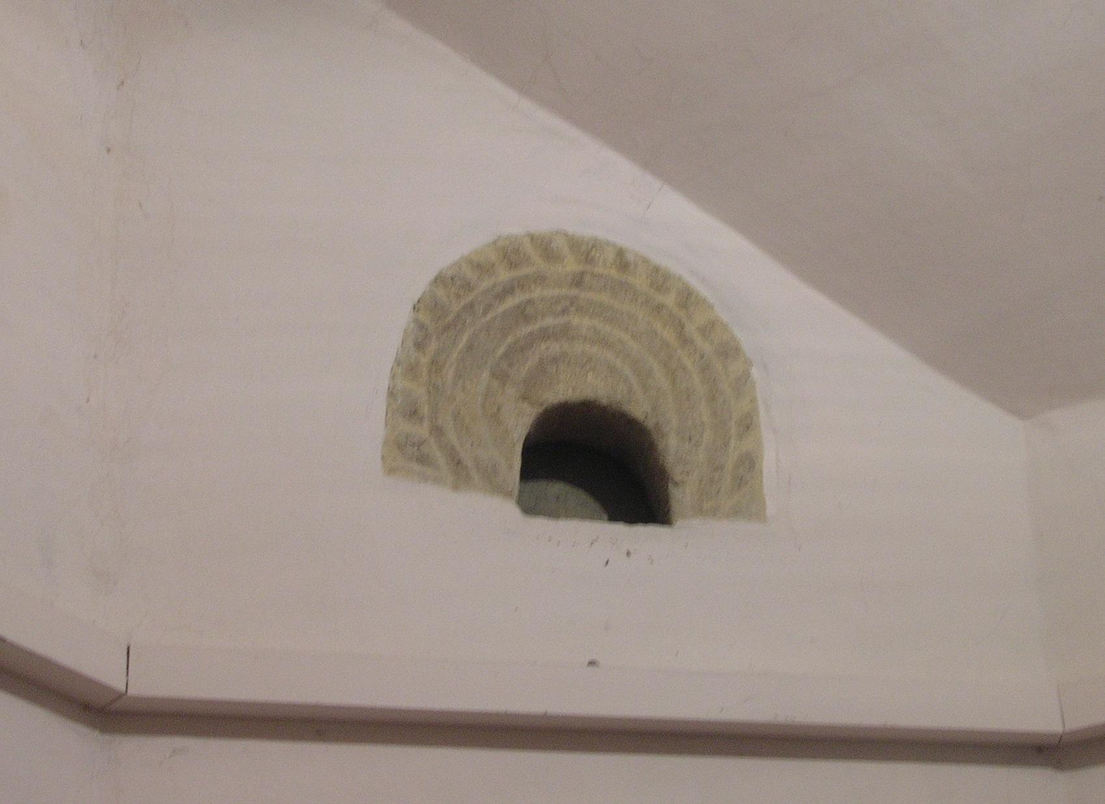The window head looks Anglian. There is a similar one at Kirkburton. The Rylstone one looks recut as if the decoration belongs to something else and is recut as a window.
The decoration does not match the window arch. Possibly an Anglian church on the site, hence Chapel-of-ease?
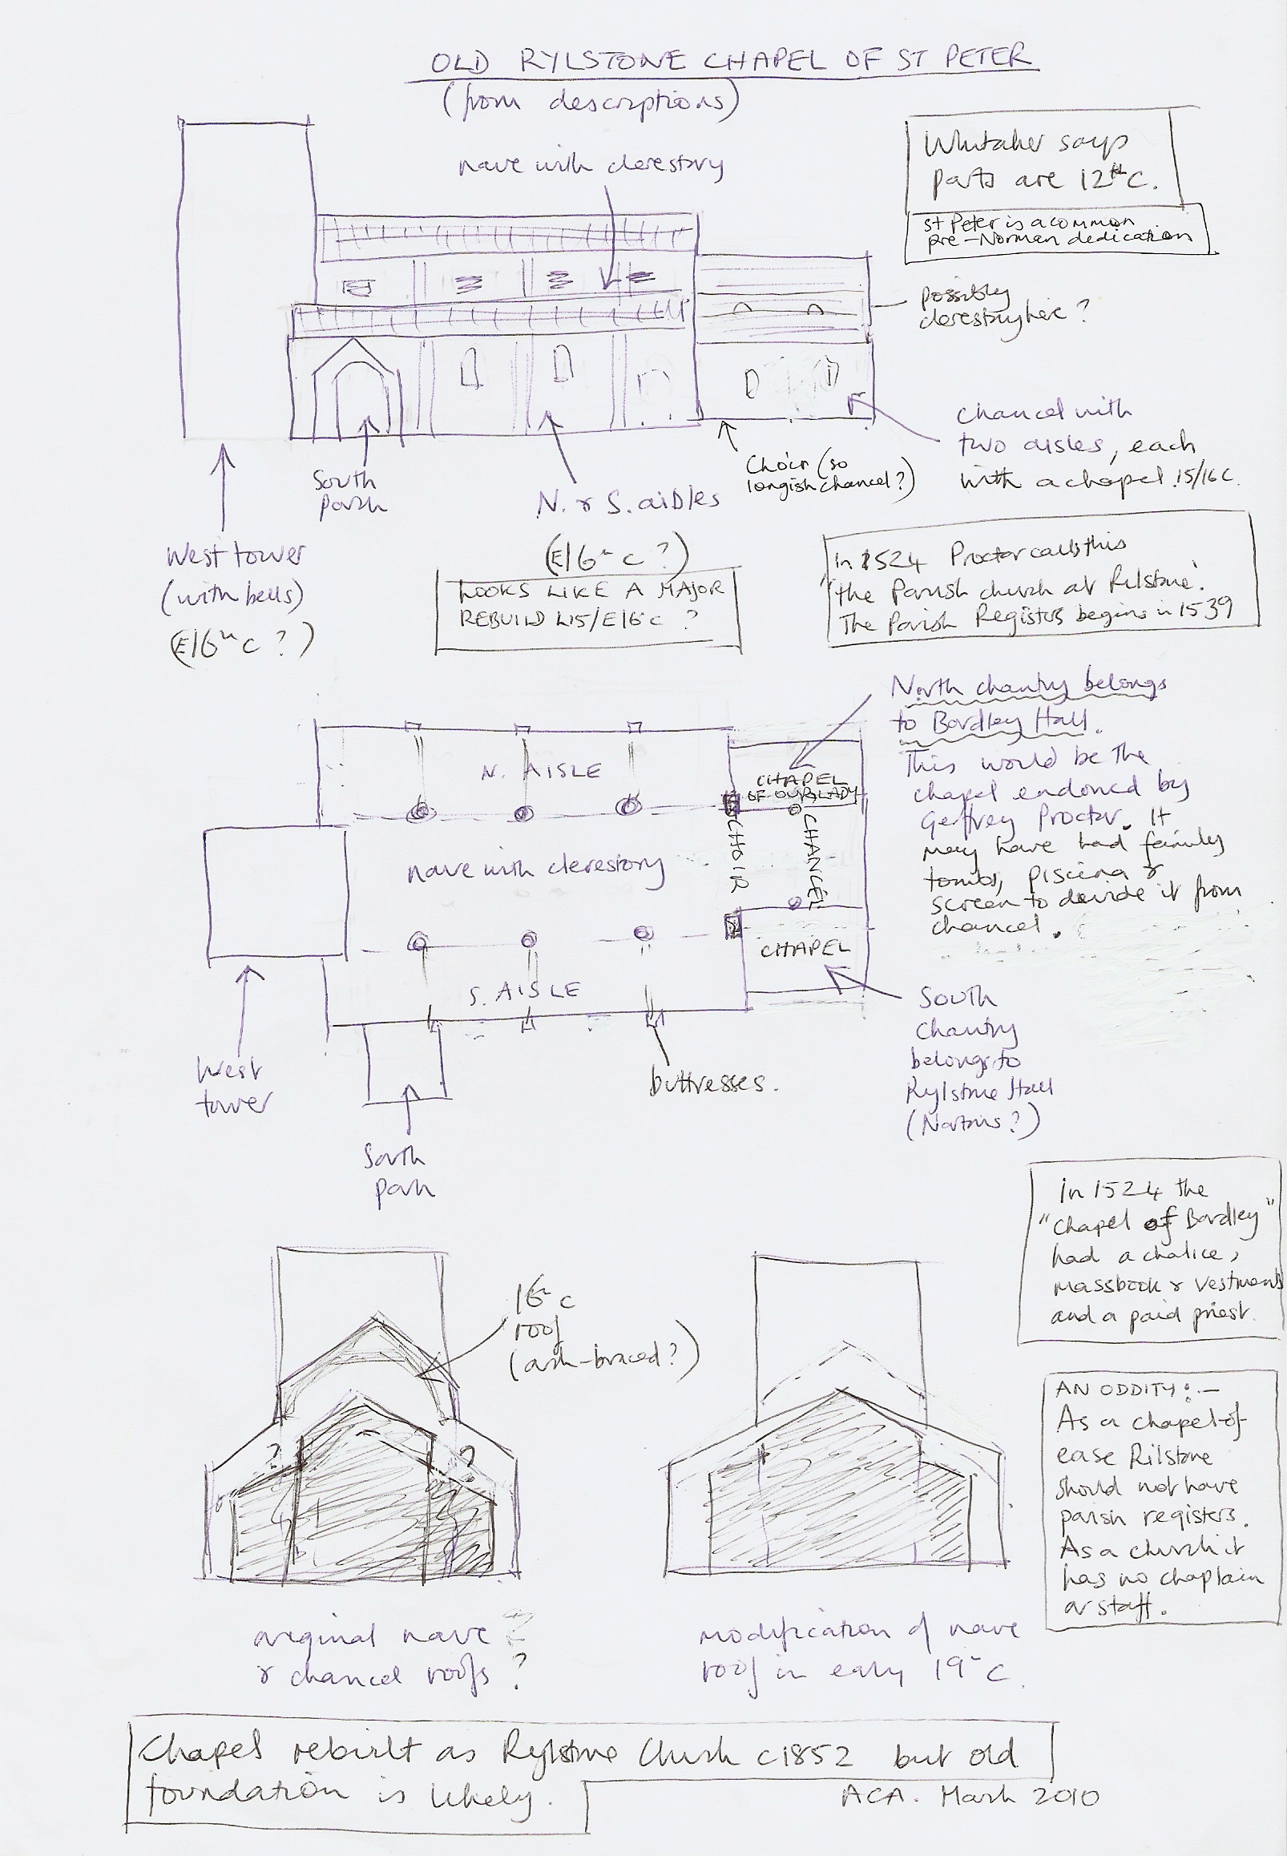
RYLSTONE CHURCH GRAVESTONES 22 March 2010 Lynne

Gravestones in floor at E end of Nave going from N – S: (Outside graves to check – in summer!)

1. Here lies the body of Mr David Yates of Lainger House who departed this life February 20th in the 83rd year of his age AD 1733.

2. Here lies the body of Mrs Susanna Yates wife of Mr David Yates who departed this life March the 7th day in ye 35(?)th year of her age AD 1733.

3. (Under central carpet) In memory of Elizabeth Procter wife of Robert Procter of Bordley and daughter of Anne Parkinson of Hetton who departed this life the ..... day of September 1809 (?) aged 61 years. Also the above Robert Procter who departed this life the 20th day of August 1810? 1812? aged 74 years.

4. Here lies the body of Mrs Sarah Yates daughter of Mr David and Mrs Susanna Yates of Lainger House who departed this life March the 29th day AD 1742.

Several more gravestones south of these but under pews. May all be people from Rylstone.

2 stones in central aisle, under carpet, (edges missing as have wooden base for pews built on top), going E – W:

1. Here lies the body of Mrs (?) Frances (?) Yates (?) ............................ 20 th (?) day of April in the year of our Lord ...6 aged 75 years.

2. Here lye the bodies of John and Nicholas sons to James Parkinson of Hetton who departed this life, Nicholas the 6th of August in the 3rd year of his age and John the 3..th (doesn’t look like 0!) of August in the 5th year of his life 1741. We lye interred within this silent(?) grave. No wealth, no want, no earthly friends .........crave our parents may rejoice to see for why we are gone before, in .... into felicity. Also Joshua, son to ye James Parkinson... (rest missing).

Useful documents in the Vestry:
* Register of St Peter’s, Rylstone - C H Lowe, 1895
Contains Births/Baptisms, Marriages, Burials 1559 -1723. Looks a v useful book. 2 of many refs to Bordley: p.46 Christening – Elizabeth John Airton Dec 3 1611 Bordley
p.58 Christening – Elizabeth John Airton Bordley June 11 1620.
*Rylstone Register of Burials 1901-
*Rylstone Register of Baptisms 1889-
P44 mentions the baptism 0n 24 September 1960 of a child of Michael & Sheila Gurney at Knowle Bank Farm. Stuart Smith knew some people called Gurney who came from East Anglia and may have been Quakers. Is this the Quaker link with KBF?

