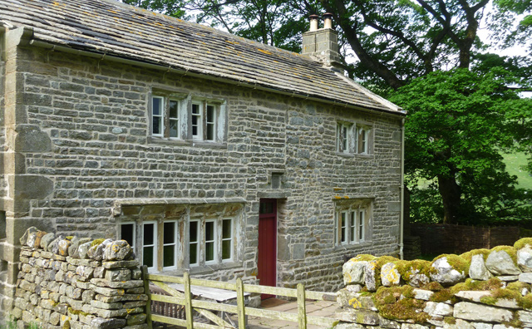

Cowside
Cowside is significant as an unaltered example of a late 17th/early 18th-century farmhouse of the North Yorkshire Dales. It is entirely typical of its area in many respects, but in a few it is unusual, not to say exceptional. The farmstead is set on the fellside above the young River Wharfe, just after it has been christened as such at the meeting of the becks at Beckermonds.
It is made up today of the farmhouse, two attached outbuildings or barns, a poultiggery (henhouse and piggery combined), former privy and various enclosures created out of the ubiquitous Dales drystone walling. In facing south up the slope and away from the river, Cowside perhaps seems to turn its back on the world, but more likely is that there was once a packhorse trail running along the contour line above it, (the Dale was an important through route from Lancaster to Newcastle-upon-Tyne).
There is a datestone “I S 1707” above the front door, but a panel of disturbed masonry around it indicates that it has been re-set from a two-storey porch (since lost), a common feature on houses of that date. The porch’s existence was proved when we found a blocked doorway under plaster on the first floor. The front elevation has a set of fine stone mullioned windows with an echo of earlier centuries about them, placed with a careful symmetry that was very up to date for the early 18th century. The rear elevation is interesting for different reasons. It has an unusual twin gabled service range, of a stair tower with a pair of two storey service chambers to each side. The windows on this less public side are various, clearly re-used or even cobbled together from pieces of salvaged stonework, some arched, some little more than square openings. Whether they came from an earlier building on the same site or elsewhere is not known.
There has been much debate about when Cowside was constructed, and documentary references suggest there was a farm called Cowside in Hubberholme parish by 1682, when Jane, wife of Francis Slinger of Cowside, was buried. Dendrochronology (dating by tree ring analysis) proved inconclusive (although the main roof structure is of oak, the joists and internal joinery are thought to be mostly ash). The safest to say is that the house was built around 1700, and probably as an extension of activity by the prosperous Slingers of Beckermonds, who are known to have been living at Beckermonds in the 1660s.
The farmhouse itself is a simple two cell, direct entry house on two floors. It is built of the local, highly durable limestone with freestone quoins and dressings. As originally built, the entrance led straight into a hall/housebody (today’s kitchen) with a massive inglenook fireplace under a stone arch and a fine six-light stone mullioned window with window seat beneath. In the 18th century, a self-contained stone fireplace was inserted into this massive hearth and the flue narrowed. Probably in the early 19th century, perhaps when the porch was taken down, the partition wall to the left of the main entrance was inserted to create a through passage (and no doubt better insulation from the draughts). Now across this passage is the parlour, the finest room in the house with another good stone fireplace and wall paintings. These paintings are an exceptionally rare survival in this remote corner of Yorkshire, and noteworthy in a vernacular building even beyond. On the walls to either side of the window, they are monochrome Biblical texts in Gothic script, surrounded by flamboyant frames of foliage and scrolls. They are clearly the work of skilled hands, and by two different artists.
On the west wall is Whether ye eat, or drink or whatsoever ye do do all to the glory of God Corinthians X:31 and For of him and through him, are all things: to whom be glory for ever. Amen. Romans XI:36.
On the east wall is Better is a dinner of herbs where love is than a stalled ox and hatred therewith Proverbs XV: Chapter 17 verse.
We know that a William Slinger of Langstrothdale went to Sedbergh School in the 1670s before going on to Cambridge University and becoming a clergyman. It is quite possible that he was Frances and Jane Slinger’s son, growing up at Cowside in a prosperous and educated household with these cheerful texts, although there is no definitive proof. Both these main ground floor rooms have fine beams with well carved ogee stops.
To the rear of the ground floor are a former dairy on one side (now a scullery) and a washhouse on the other. Before restoration, the dairy still had remnants of shelving and the washhouse a copper for boiling clothes. Note too the stone spout for waste water which projects through the wall. There is a very small cellar below the stone dog leg stairs. The banisters and newel post had completely disappeared, now reinstated on the basis of other local examples.
Upstairs, the hall chamber was heated only by heat radiated from the massive chimneybreast. The parlour chamber was clearly the best bedroom, with a third well-made fireplace with capitals and a mantelshelf. The window has a well-shaped central king mullion. It seems both these rooms were originally open to the rafters, perhaps until as late as the mid-19th century
from https://heritage.directory/properties/the-landmark-trust/cowside

