EARLY HISTORY
Austwick is a very old settlement, dating back to at least Viking times. ‘Austr’ is Old English ‘eastern’ – probably meaning east of Clapham, and ‘wic’ is a Scandinavian word, usually meaning an outlying specialized farm or dwelling, so we have perhaps ‘Eastern dairy farm’.
(A. Room, The Penguin dictionary of British Place Names, Penguin 2003).
The parish appears in Domesday book (1086) under the name Oustewic. From Saxon times there was a parish system in England, but we cannot date with certainty the formation of Clapham parish of which Austwick was a part. However, this was almost ceratinly before the time of Henry I (1100-1135) and there is mention of a vicar of Clapham (Adam) in 1160.

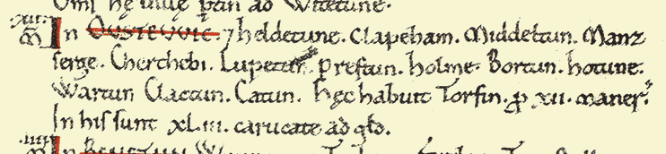

(C. P. Lewis, An introduction to the Lancashire Domesday. The Lancashire Domesday, ed. Ann Williams and E. H. Morton, London 1991.)
King William placed two Norman tenants-in-chief on lands north of the River Ribble. They controlled lands near the coast but did not disturb the pre-Conquest organization of local society. Austwick belonged to a group of vills owned by Thorfinnr (a Scandinavian or Old Norse name). He was a wealthy thegn who owned land all over Yorkshire and was the most important landowner in West Yorkshire.
There are pre-historic settlement remains - on Crummock and longhouses in Kingsdale. There is a Romano-British settlement of the 2nd or 3rd century on the footpath to Clapham. There are early medieval strip lynchets around Austwick. There is ridge and furrow in the local fields and evidence of 18th and 19th century enclosures with stone walls – often cutting across lynchets and ridge and furrow.
The Manor of Austwick
The lordship and lands of Austwick changed hands several times in the 16th century. After Dissolution in the 1530s the Duke of Suffolk sold the manor to Sir John Yorke in 1551. The manor house and demesne land of Austwick were separate from the lordship and were bought in 1573 by the Ingleby family. In the following year the Inglebys also bought Lawkland Hall.
Sir Richard Shuttleworth of Gawthorpe, Lancashire bought Austwick manor in 1599 for £1200. Sir Richard was a successful lawyer in London. He became Serjeant-at-Law in 1584, was knighted by Queen Elizabeth and appointed Chief Justice of Chester in that year. He made a fortune in London and invested his money in land. Soon after buying Austwick Manor he died at Smithills Hall near Bolton. His brother Lawrence inherited the title and lands. A portrait of Lawrence Shuttleworth in the possession of Lord Shuttleworth was painted in 1600 just after he became lord of the manor. The Shuttleworths continued to own the lordship until 1782 (hence the terminal date on some of the court books). The manor passed to James Farrer of Clapham in 1782.
The Yorkshire Historical and Archaeological Society holds the Manor Court Book (DD91) for 1681-1714 and this has not yet been transcribed from digital images (M. Pearson). Michael Pearson has transcribed the Court Baron Records for 1693-1783. All these are in the custody of the Special Collections Library at Leeds University.
The NYCRO Z1080 mic 4328/1 and /2 concerns a copy of the Court Baron proceedings for 1787 – 1816 (Part 1) and 1817 – 1839 (Part 2 and Index) made in about 1820. These two parts have been transcribed by Sheila Gordon from photocopies made by the North Craven Heritage Trust and held in NCHT archives. They can be seen online at www.dalescommunityarchives.org.uk under Manorial Records for North Craven. A study of these records remains to be written.
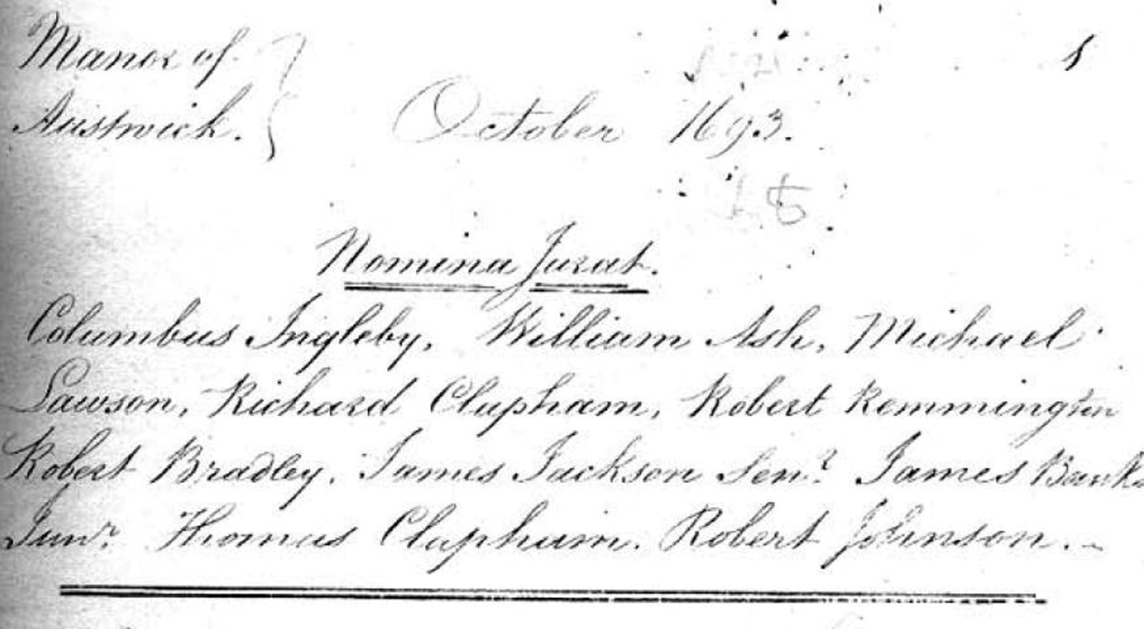
Manorial Customs for the ‘Customary Manors which lie west of Settle are those of Lawkland cum Feizor, Austwick, Clapham, Newby, Ingleton & Thornton in Lonsdale’ are described in a document held in Skipton Library (MNR/009 and NRA 10242 ref. 567 undated but post 1800). For Austwick, on change of tenants a fine is payable to the lord of three years customary rent.

